**Empowering Agencies**With Seamless Workflow Solutions

Optimize Your Agency’s Workflows with Our Comprehensive Cloud-Based Platform

Top of Form

Email

Book demo

Bottom of Form

**Streamline and Optimize Your Agency’s Operations**

Nexelus is a comprehensive, cloud-based operations management solution designed specifically for marketing agencies. Our clients seek a true SaaS platform that simplifies and optimizes their operational workflows—all within one easy-to-use interface.

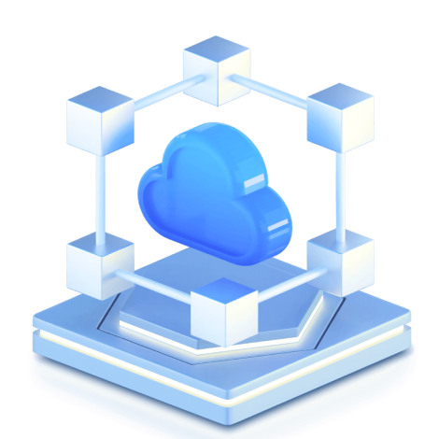

Our Adtech  
**Partners**

Component 134

Component 134

Component 134

Component 134

**Integrated Tools to Manage  
Your Operations**

**Digital Media  
Management**

Effortlessly manage digital media buys across all major Ad Tech platforms.

**AI-Powered  
Accounts Payable**

Automate vendor invoices and approval processes for faster financial management.

**Real-time  
Dashboards**

Keep track of project estimates, costs, billing and profitability in one view.

Optimize Your Agency Workflow with Nexelus

Job & Campaign  
Financial Management

Workforce  
Optimization

Best  
Practices

Cloud-Based,  
Flexible & Modular

**Explore Nexelus in Action:**Key Features at a Glance

AP Workflow

Digital Media

Job Management

Resource Management

Time & Expense Management

**End-to-End Automation for Digital Media Management**

From campaign planning to billing and reporting, Nexelus covers every step in the digital media process, ensuring efficient, integrated workflows for marketing agencies.

Campaign, RFP, Media Plan

MA/ATB, Buying/IO, Ad Tech Integrations

API Access To Underlying Data

Dashboards, KPIs, Reports

Actual Delivery, Pacing, Optimization, Collaboration

Bill/Pay (including Print/TV/Radio), Automated Invoice Matching & Reconciliation, Finance & Accounting

**Optimize Your Workforce and Maximize Efficiency**

Nexelus empowers marketing agencies to effectively manage projects, tasks and resources, ensuring the right talent is matched with the right tasks while optimizing overall performance.

Project & Task Management

Collaboration, Document Management & Routing

Staff Planning, Smart Matching

Risk Analysis

Client & Project Health

Staff Utilization

Revenue Projection

Revenue Contribution (department, location, individual)

Opportunity Cost Analysis

**Comprehensive Financial Management for Projects and Campaigns**

From budgeting and billing to revenue recognition and accounting, Nexelus offers a complete suite of financial tools that ensure transparency, control and accuracy in managing your projects and campaigns

Dashboards & reports

Project Workflow & Timesheets

Expense Reports & Mobile App

Budgets & Estimates

Studio Management

Purchase Orders & Vendor Invoices

Billing, WIP & Cost Accounting

Revenue Recognition & Client/Project P&L

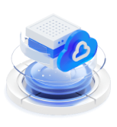

**Scalable Cloud Infrastructure for  
Seamless Integration**

Built on Microsoft Azure, Nexelus offers a flexible, cloud-based SaaS platform that integrates seamlessly with ERP systems, Ad Tech platforms and the broader digital media ecosystem.

Microsoft Azure

Webservices/APIs

Cloud-Based SaaS Platform

Pre-Built Integrations

Open System Architecture

Data Flexibility

Unique Integration with Digital Media Ecosystem

**Modular Solutions Tailored  
to Your Needs**

Nexelus allows you to fully automate your agency’s operations or select the modules that best fit your current tech stack and workflows. Leverage individual components for maximum efficiency or integrate them seamlessly for full-service automation.

Full Service Automation

Utilize Individual Modules for Efficiency

Utilize Database as a Service

Integrate with Your Current Tech Stack

**Modular SaaS platform that provides a single total solution or leverage individual “independent” functionality usage**

Digital Media

AI based AP Workflow Automation

Creative, Production and Job/Project Management

[Book demo](https://nexelus.gotit.pk/#elementor-action%3Aaction%3Dpopup%3Aopen%26settings%3DeyJpZCI6IjExODciLCJ0b2dnbGUiOmZhbHNlfQ%3D%3D)

**Why Nexelus?**

**Operate more efficiently**, transparently & profitably

**Optimize** project &  
campaign workflows

**Enhance speed** &  
precision

**Gain insights** with real-  
time dashboards



We’ve been using Nexelus to kick start every new project and can’t imagine working without it.

Candice Wu

Product Manager, Sisyphus

](https://nexelus.gotit.pk/)

* [About Us](https://nexelus.gotit.pk/about-us)
* [Security & Compliance](https://nexelus.gotit.pk/security-compliance)
* [Contact Us](https://nexelus.gotit.pk/contact-us)

© Copyright 2024, All Rights Reserved